- Draw the different rooms in your home.
- Write the names of the room using the words on the board.

Rooms in my home.

#

- Tick the correct box.
- Tick the correct box.

I live in a …

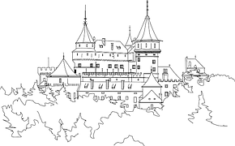
CASTLE
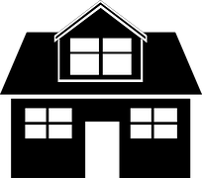
HOUSE

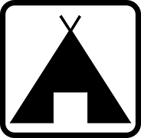
TENT
FLAT

- Using the flashcards, match the word with the picture and then write the word in the room where it belongs.

What belongs where?

BATHROOM
BEDROOM

LIVING ROOM
KITCHEN

- Using the scaffolding on the board, write about your own home.

My home…

- Write your name and class and colour in your front page .
- Write your name and class and colour in the front page.
NAME:

- Fill in the gaps with the correct room.

- Fill in the gap with the correct room.

- I sleep in my______________________.

- I cook in my ________________________.

- I brush my teeth in my __________________.

- I watch TV in my ___________________________.

- I eat my dinner in my _________________________.

bathroom kitchen living room
bedroom dining room

MY
STATIONS

VIDEO:Me and My Home
VIDEO: My New Home
WS: I live in a…
WS: Rooms in my home
WS:What belongs where?
WS: Fill in the gaps.
WS: My home…
Mini Lük
SPEAKING EXERCISE
Learning App In my home
Me and My Home Reading Quiz

