- Draw the different rooms in your home.
- Write the names of the room using the words on the board.

Rooms in my home.

#

- Tick the correct box.
- Tick the correct box.

I live in a …

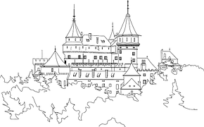
CASTLE
HOUSE

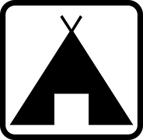
TENT
FLAT

- Using the flashcards, match the word with the picture and then write the word in the room where it belongs.

What belongs where?

BATHROOM
toilet
sink
bath
BEDROOM
bed
wardrobe

LIVING ROOM
television
sofa
KITCHEN
fridge
oven
dining table

- Using the scaffolding on the board, write about your own home.

My home…

- Write your name and class and colour in your front page .
- Write your name and class and colour in the front page.
NAME:

- Fill in the gaps with the correct room.

- Fill in the gap with the correct room.

- I sleep in my____bedroom__________________.

- I cook in my _________kitchen_______________.

- I brush my teeth in my ____bathroom_____________.

- I watch TV in my ____________living room_________.

- I eat my dinner in my ___dining room_____________.

bathroom kitchen living room
bedroom dining room

MY
STATIONS

I live in a...
Rooms in my home…
What belongs where?
Fill in the gaps…
My home…
Rooms in the house COMPUTER
Rooms and Furniture COMPUTER
Game COMPUTER
Mini Lük
SPEAKING EXERCISE

